Front End Engineering-II

Project Report Semester-IV (Batch-2022)

**WEATHER APP**



**Supervised By: Submitted By:**

Dr. Raveesh Samkaria Saniya Singla

2210990789

G-31

**Department of Computer Science and Engineering Chit- kara University Institute of Engineering & Technology,**

**Chitkara University, Punjab**

# Abstract

aniya This user-friendly weather app “Weather In” empowers you to stay informed about current and upcoming weather conditions with ease. Built upon the robust foundation of Bootstrap, the app boasts a responsive and visually appealing interface that adapts seamlessly to any device, from desktops to smartphones.

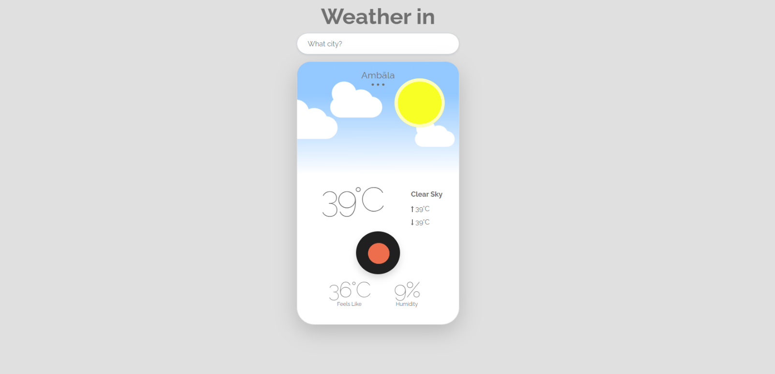

# INDEX

|  |  |  |
| --- | --- | --- |
| **S.No.** | **Title** | **Page Number(s)** |
| 1 | Introduction | 4 |
| 2 | Problem Statement | 5 |
| 3 | Software Requirements | 5 |
| 4 | Proposed Design | 6-13 |
| 5 | Results | 14-17 |
| 6 | References | 18 |

1. **Introduction**

The Weather In web application offers a convenient yet efficient platform for checking weather based on current location. In today's digital age, where convenience and accessibility are paramount, such tools provide valuable assistance in everyday tasks. This introduction provides an overview of the background, objectives, and significance of the “Weather In”.

## Background:

As technology continues to permeate various aspects of our lives, the need for quick and easy- to-use utilities becomes increasingly apparent. The “Weather In” web app addresses a fundamental need i.e. the ability to check accurate weather anytime needed and anywhere needed . With the proliferation of web-based applications, users expect seamless experiences that deliver results promptly and accurately.

## Objectives:

The primary objective of the “Weather In” is to provide a user-friendly interface for individ- uals to input city name and obtain the weather instantly. This application aims to simplify the process, eliminating the need for users to browse through internet or rely on external tools. Additionally, the “Weather In” web app strives to ensure accuracy.

## Significance:

The significance of the “Weather In” web app lies in its ability to streamline a common task that individuals encounter regularly. Whether for personal use, professional purposes, or administrative requirements, knowing the weather accurately is essential. By offering a convenient and reliable solution, the “Weather In” web app enhances efficiency and productivity, saving users time and effort.

# Problem Statement

Existing weather forecast web apps are cluttered with useless information and prone to errors, lacking accuracy and user-friendliness. Current online applications often overlook various factors compromising accuracy. There's a need for a precise, intuitive, and accessible Weather app that ensures accuracy while considering all relevant factors, catering to users' diverse needs across different platforms and devices. Additionally, the lack of attention to detail in existing solutions hinders their reliability and usability, resulting in frustration for users seeking quick and accurate weather information.

# Software Requirements

## Integrated Development Environment (IDE):

* + Visual Studio Code (VS Code) for code editing and project management.

## Frontend Technologies:

* + HTML: Markup language for structuring the web application.
  + CSS: Styling language for enhancing the presentation and layout.
  + JavaScript (JS): Programming language for implementing interactive features and logic and making the API call.

## User Interface (UI) Framework:

* + Bootstrap 5: Frontend framework for building responsive and visually appealing user interfaces.

## Version Control:

* + Git: Distributed version control system for tracking changes in the project codebase.

# Proposed Design

* **User Interface Design:** Utilize Bootstrap 5 for a responsive, visually appealing lay- out.card-based design for intuitive organization.
* **Frontend Development:** Develop using HTML, CSS, and JavaScript. Utilize HTML5 semantics, CSS for styling, and JavaScript for dynamic UI updates.
* **User Experience Optimization:** Focus on real-time feedback, interactive ele- ments, and cross-browser compatibility. Ensure responsiveness for varied devices.
* **Documentation and Deployment:** Provide detailed documentation. Deploy on web server with domain. Maintain and update documentation regularly.
* **Availability for the Community:** This project is available on Github on my Profile in a public repository so that people can check it out and can learn.

## File Structure

Ensuring proper file and folder structure to maintain consistent file paths and clean structure.

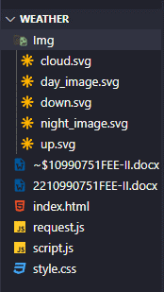

## HTML Code Structure

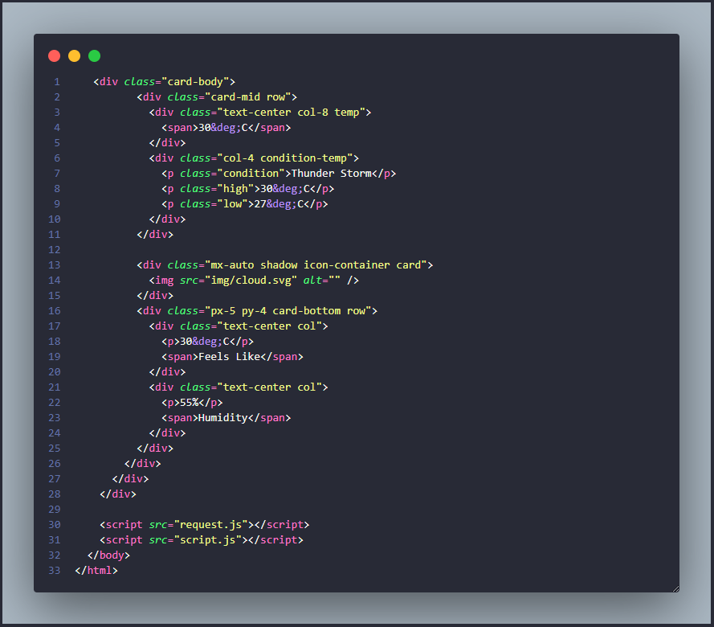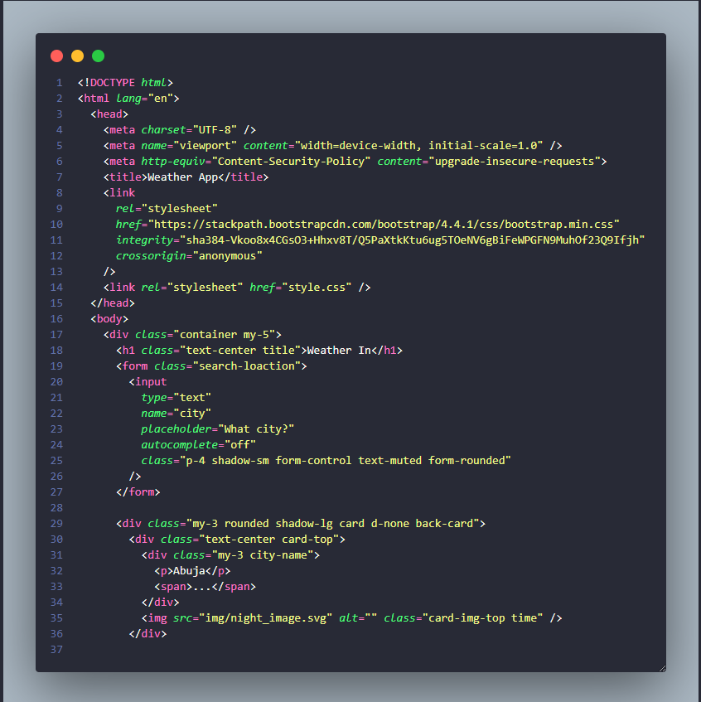These screenshots present the HTML code for our ”Weather In” web app project, revealing the layout and content of our web pages in a code format.

## CSS Code Structure

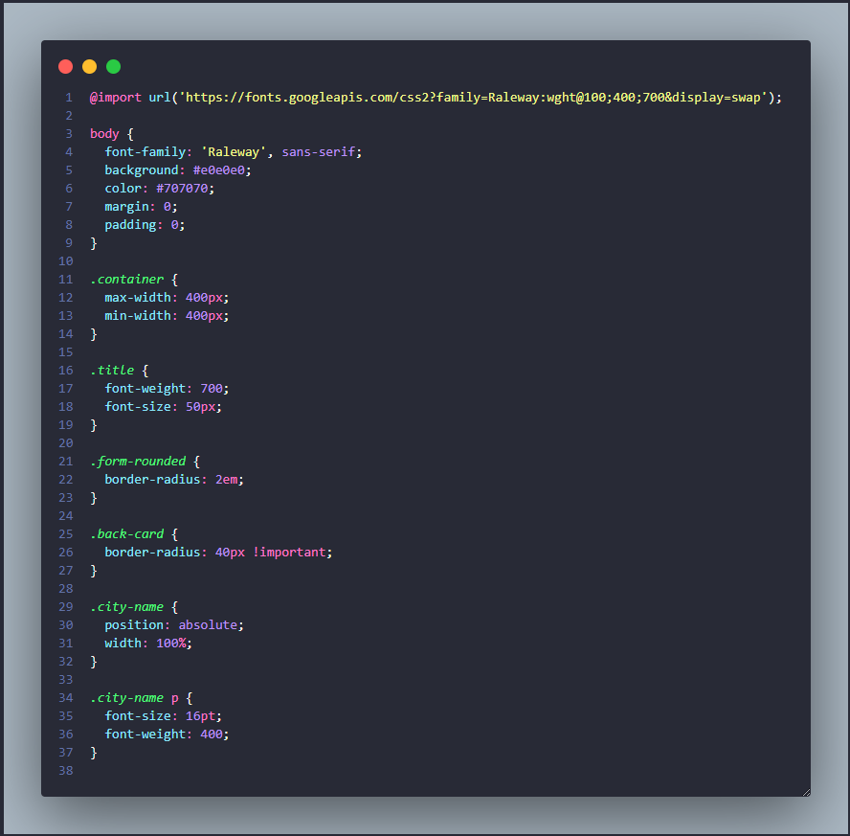This screenshot exhibits the CSS code for our “Weather In” web app project, illustrating the styling and design elements implemented across our web pages.

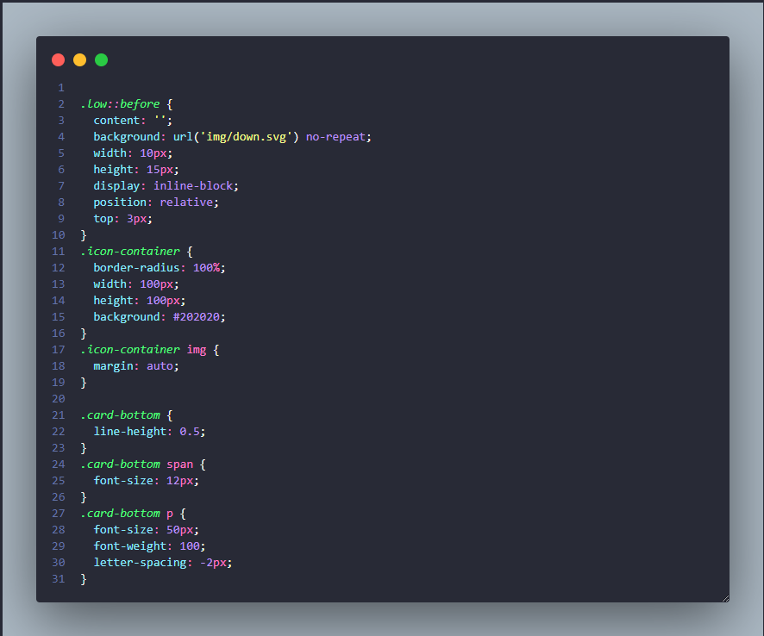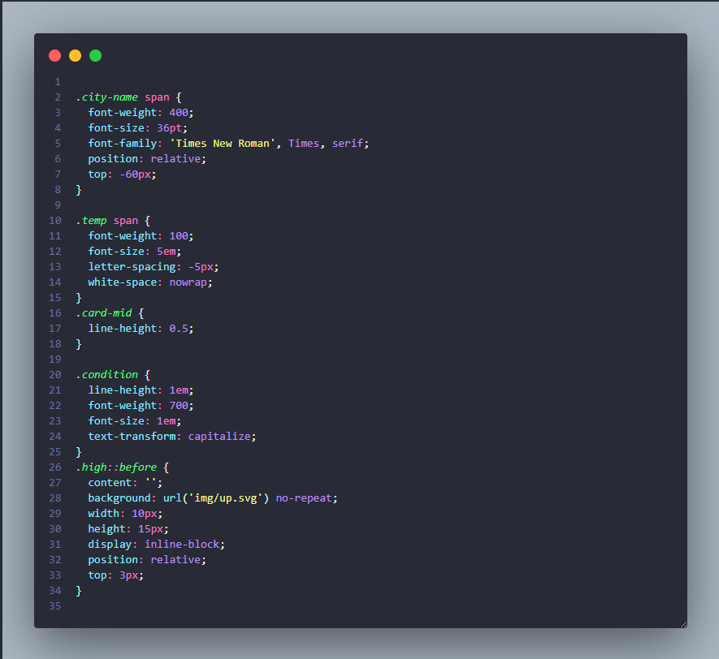

## Javascript Code Structure

This screenshot exhibits the JS code for our “Weather In” Web app project, illustrating the different functions, events and API Calls we trigger according to different scenarios.

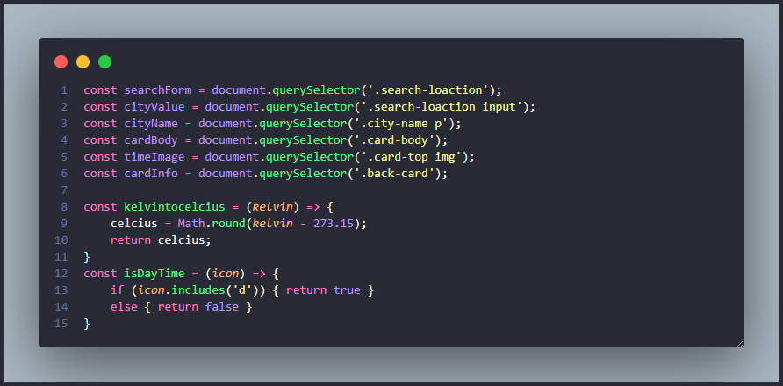

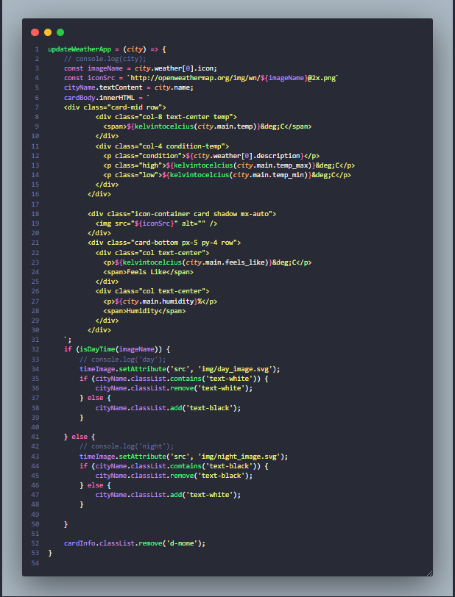

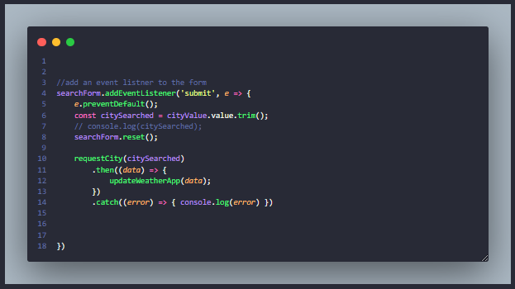

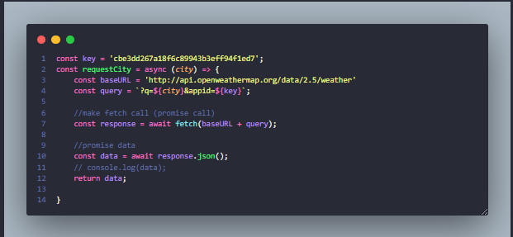

# Results

The “Weather In” application successfully fulfills its intended purpose of accurately showing the Weather in the entered Area. Through rigorous testing and user feedback, the following key outcomes have been achieved:

**GitHub Repository Link:** [coolguy-codin-Rydham/WeatherAppBootstrap (github.com)](https://github.com/coolguy-codin-Rydham/WeatherAppBootstrap)

**Deployed Via Vercel Link:** [Weather App (weather-app-bootstrap.vercel.app)](https://weather-app-bootstrap.vercel.app/)

## Project Screenshots for all scenarios:

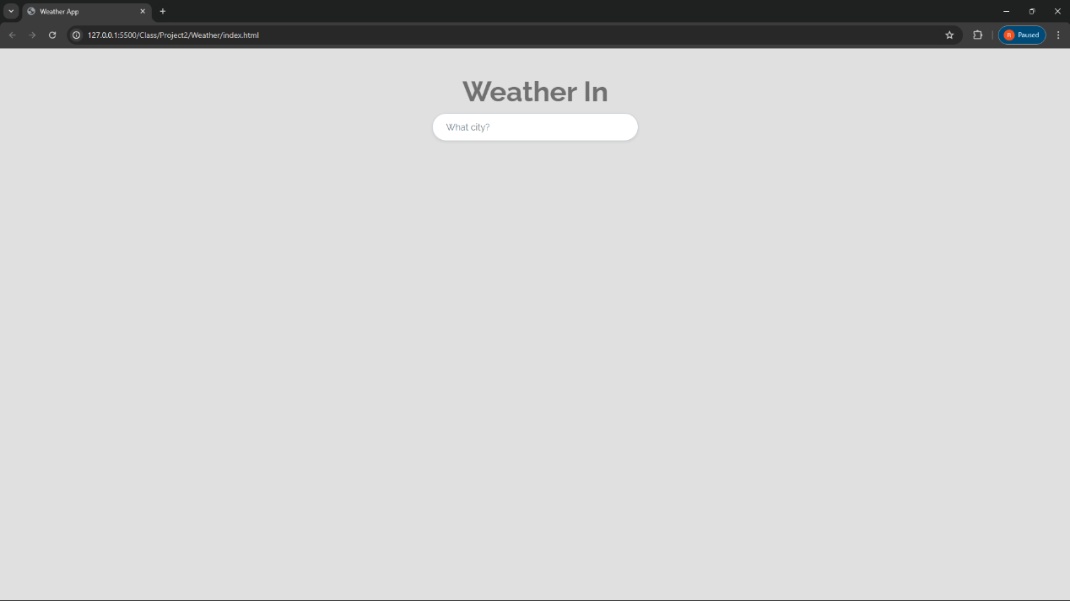

Static Scenario

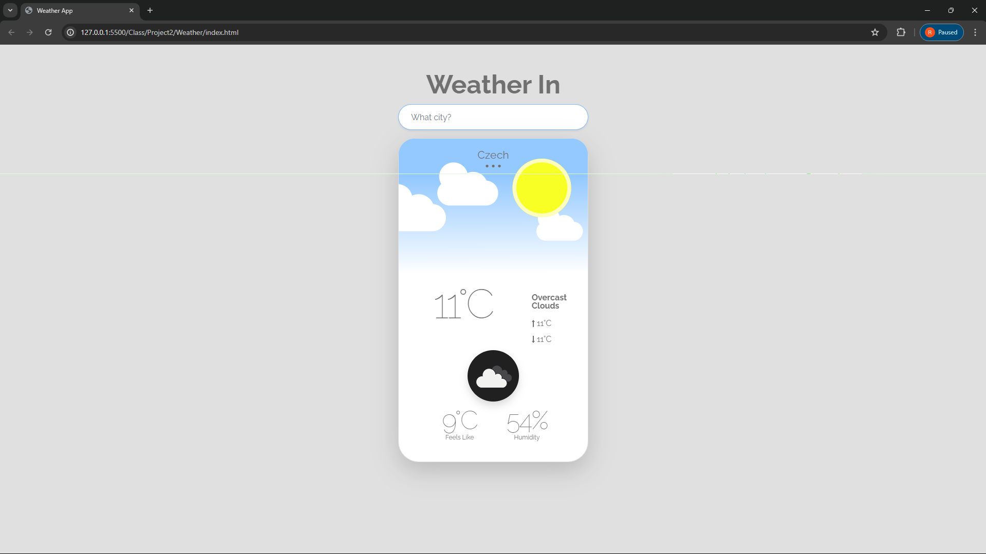

Data Presenting Scenario

* **Accuracy:** The “Weather In” logic, implemented in JavaScript, accurately determines the weather in the entered Location.
* **User Experience:** The user interface design, leveraging Bootstrap 5, provides a seamless and visually appealing experience across different devices and screen sizes. Interactive ele- ments and real-time feedback enhance usability and engagement.
* **Functionality:** Users can easily input city name through the intuitive interface, trigger- ing the API call process with the click of a button. The fetched Weather is displayed dy- namically.
* **Documentation and Deployment:** Comprehensive documentation guides users through setup, usage, and troubleshooting. Deployment on a web server with domain access ensures public availability, while regular updates maintain relevance and accuracy.
* **Availability for the Community:** This project is available on Github on my Profile in a public repository so that people can check it out and can learn.

Overall, the “Weather In” application delivers on its objectives, providing users with a reliable, intuitive, and enjoyable tool for determining the weather with ease and accuracy.

# References

## HTML, CSS, and JavaScript Documentation:

* + **Mozilla Developer Network (MDN) - HTML:** https://devel- oper.mozilla.org/en-US/docs/Web/HTML
  + **Mozilla Developer Network (MDN) - CSS:** https://developer.mozilla.org/en-

US/docs/Web/CSS

* + **Mozilla Developer Network (MDN) - JavaScript:** https://devel- oper.mozilla.org/en-US/docs/Web/JavaScript

## Bootstrap Documentation:

* + **Bootstrap Official Documentation:** https://getbootstrap.com/docs/5.3/getting- started/introduction/
  + **W3Schools Bootstrap Tutorial:** https:/[/www.w3schools.com/bootstrap/boot](http://www.w3schools.com/bootstrap/boot-)- strap_get_started.asp

## Frontend Development Tutorials and Articles:

* + **CSS-Tricks:** <https://css-tricks.com/>
  + **JavaScript.info:** <https://javascript.info/>
* **API Reference:**
  + **Link:** [Weather API - OpenWeatherMap](https://openweathermap.org/api)